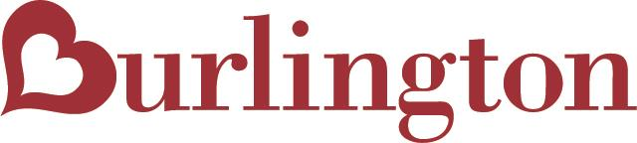

CORONAVIRUS UPDATE

We appreciate your patience during these times as the Coronavirus (COVID-19) is impacting the world in an unprecedented way. Like you, we are facing unique challenges as we all strive to keep our employees and communities safe. As a result of various government mandates and other actions we have closed many of our stores for an undetermined period of time, and may have to close many more as this pandemic progresses. For this reason we will not be accepting any routing requests or new requests for appointments at any of our distribution centers. This change will remain in place indefinitely. We look forward to a day in the not too distant future when things will return to normal for all of us.
If you have further questions please reach out to vendor.relations@burlington.com

